[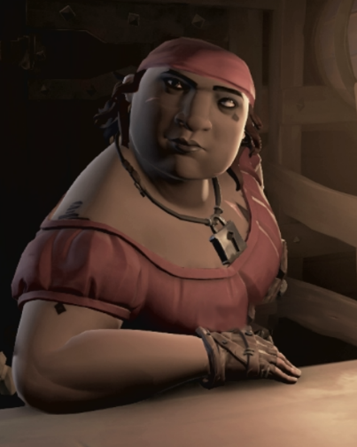](https://www.google.co.uk/url?sa=i&url=https://seaofthieves.fandom.com/wiki/Tasha&psig=AOvVaw0wmNawSPoj5J49ETfYxWyB&ust=1592404159279000&source=images&cd=vfe&ved=0CAIQjRxqFwoTCKDIsP3FhuoCFQAAAAAdAAAAABAD)

**Martha The Tavern Keeper –** Hey! You there. I need your help. Recently a group of renegade bandits have been breaking in here and destroying my tavern! I can’t let them find the key to this place. The Tavern has been in my family for generations. I keep the key in one of those barrels over there. The only way to get it is to use a hammer to break it. I have a hammer in that chest of drawers over there, but I’ve forgotten the code. I have left a note somewhere around here with means of working out that code. If you could get the key before the bandits do, I might have a chance of protecting my tavern from being taken over them.